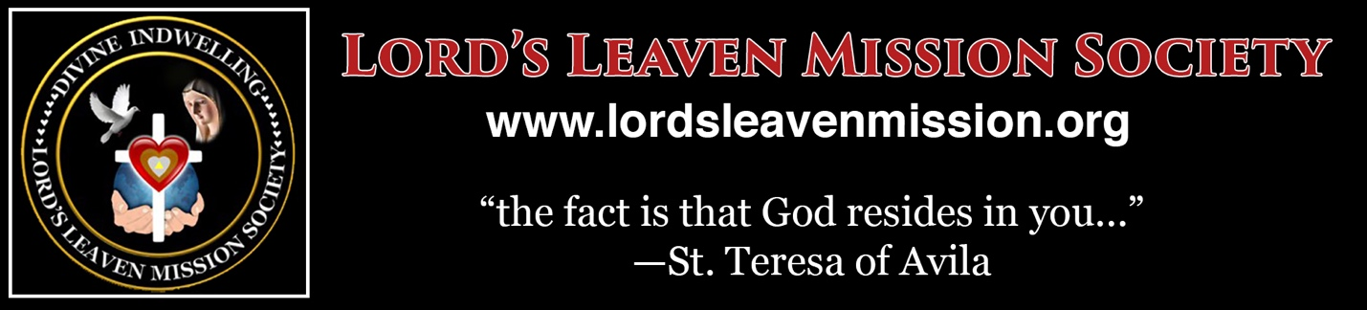
TO Brothers and Sisters

FROM: Bro. Josefino T. Rona
Global Shepherd
RE: Directive from the Bishop and our Mission Spiritual Director
Let us thank God and the Blessed Mother for giving us the grace to serve God and the Church.
The Lord’s Leaven Mission Society (LLMS) is a canonical society in the Church since September 29, 2014 under Bishop Honesto Ongtioco of the Diocese of Cubao. This approval was renewed on June 1, 2019.
With this renewal the Bishop has advised us that all members of the Family Cenacles who would like to join the Mission undergo formation on the Spirituality of the Society based on its Constitution and its Guidelines under the guidance of the Global Shepherd and the Spiritual Director assigned by the Bishop. The Bishop wants to know who are those who take up the SPIRITUALITY of the Lord’s Leaven Mission through the Pastoral Management Institute (PMI) of the Society. He would like to commission everyone who may accomplish the academic and practicum training in the lessons of the Mission upon recommendation of our Global Shepherd and our Spiritual Directors.
Fr. Hector Jay Lituanas, a Filipino Augustinian missionary, our present Spiritual Director for the Philippines assigned by the Bishop has been guiding all Lord’s Leaven Missionaries through the Cenacle Team in our Mother Mission House in Project 4, Our Lady of Miraculous Medal Parish, Quezon City.
In the spirit of the mission may we follow a common understanding of the Spirituality of the Mission. May each one share the mission that the Lord has assigned to us.
If you are willing to know the Spirituality and the Interior Journey of the Mission In obedience to the mandate of our Bishop and our Spiritual Director, please email the Letter of Intent Form below to lordsleavenmission1@gmail.com

This blessing we share to all. God bless,
Bro. Joe Rona
Global Shepherd and Formator

************************************************************************

MISSION INTENT TO TAKE UP
THE SPIRITUALITY AND WAY OF LIFE OF THE MISSION

Note: Please fill up the form below if you are interested to know and join Lord’s Leaven Mission Society and learn what this mission is all about as inspired by Our Lord, instructed by the Blessed Mother and guided by the Church.

TO : lordsleavenmission1@gmail.com

FROM: MISSION ASPIRANT _____________________________

I __________________________ desire to learn the path into the INTERIOR JOURNEY toward Union with God and to be worthy of the mission that God has designed for me already from all eternity.

I understand that there is no compulsion here. What is required of me is my free and willing response and participation in learning this mission so that I can fulfill what God intended of me from the beginning. In this way I can help myself bring out the “treasures of God’s wisdom and knowledge from the fountain of living water” within me and to share these treasures with others as God allows me to.

For this intention, I affix my consent to be a part of the learning process of the Pastoral Management Institute (PMI) of the Mission Society in order for me to learn what and how God wants me to do here on earth before I go back home to heaven when the day come.

Full Name of Aspirant: __________________________________ Date: _______________
Email address _______________________________________ Telephone _____________
Residence and Mailing Address _______________________________________________

